EECS 493

User Interface Development

Fall 2021

Final Exam

This is a closed-book, individual exam. There are five parts.

**Unless explicitly said, multiple-choice questions have only one correct answer.**

1. For questions requiring only one answer, multiple answers will be graded as wrong. E.g., if the correct answer is A. If you answered A, you got 2 points. AB is 0 points.
2. For questions that explicitly ask you to select 2 options. E.g., if the correct answer is AB. AB is 2points. ABC is 1 point. ABCD is 0 points. BC is 0 points.

Please put your choice **in the blank**.

Please **write your name and unique name on each page** (not the UM ID). We are going to take each exam page apart for grading.

Do not write anything outside the top-left staple, the staple corner will be cut off.

Rock it!

====================

**Table of Contents**

UI Design Concepts (14pts)

UI Programming (Javascript) (14pts)

Vue.js (UI Architecture, MVC, Framework/Library/Tool, Vue) (20pts)

User-Centered Design (40pts)

Accessible and Universal Design (12pts)

# UI Design Concepts (14pts)

1. __C___ When developing user interfaces, we need to consider human capabilities and limits. Which of the following is NOT correct about human capabilities that may influence UI design? (2pts)
2. One’s working memory can only hold a certain amount of information so that UIs should not create overloads to users’ working memory.
3. According to Fitts's Law, it’s better to make the command buttons of UI bigger in size than other non-interactive elements.
4. To give users a sufficient sense of control and freedom, it’s better to ask users to type the function they are looking for than providing a menu.
5. Since users process visual and auditory information through different channels, it’s better to present users with images plus narrations than images with captions.
6. (6pts) Consider which UI design property the following examples are addressing. Put the corresponding letter in the blank. Please note that each question has only **one** answer. **Options can be reused.** Each blank is worth 1.5pts.

Efficiency (E): can you get the job done quickly + well?

Understandability (U): do you understand what’s happening and why it’s happening?

Discoverability (D): can you find new UI features?

Learnability (L): can you learn to use the interface quickly?

1. My Amazon Echo just had some new intelligence, it’s able to help me create a shopping list. I ask “Alexa, what’s the weather”, after it answers my question, in addition it says “By the way, I’m able to help you create a shopping list”. This is addressing ___D____
2. On Youtube, I can create a playlist of my favorite videos so I don’t need to look for these videos each time. This is addressing ___E____
3. In the Starbucks app, I can see my recent orders and buy the same item again. This is addressing ____E___
4. Google maps has a new feature allowing people to view COVID cases on the map. It shows the new feature on the landing page of Google Maps for users that haven’t clicked it before (as shown below). This is addressing ___D____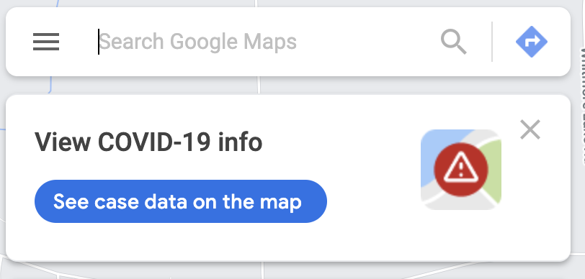
5. (6pts) Please put **one** corresponding option in the right column. Each blank is worth 1.5 pts. Please note each blank has only **one** answer. **Options can be reused.**

Affordance (A)

Signifier (S)

Metaphor (M)

Evaluation (EV)

Execution (EX)

| Statement | Answer |
| --- | --- |
| Example: I’m able to host virtual meetings through Zoom. This is a(n): | Example Answer: A |
| In Zoom, to let users know they can share screen, the button below is a(n) | S |
| In Zoom, I know I’m sharing the screen from the message at the top of the interface. This is addressing the Gulf of: | EV |
| In Slack, when I see the button (right of the image), I know I can create a new message by clicking it. This is a good signifier because it is a(n): | M |
| In Google Maps, after I land on the page, I immediately see the search bar. This is addressing the Gulf of: | EX |

# 

# UI Programming (CSS, Javascript, JQuery) (14pts)

1. __B____ Which of the following is NOT correct about UI programming? (2pts)
2. UI programming relies on the user to “tell” the system what to do, e.g., through pushing a button or typing a text.
3. UI programming is similar to programming in Java or C++, in which developers have full control on which lines of code will be executed.
4. UI programming invites user input. The user is able to change the flow and logic of the system on the fly.
5. In UI programming, we may allow users to make direct manipulation of the interface elements, e.g., change layouts on the fly.
6. ___C___Which of the following is NOT correct about asynchronous programming in JavasScript? (2pts)
7. Running complex computation in the stack may have the risk of blocking the event loop, thus making the interface less fluid.
8. The event loop is constantly running and checking, when the stack is empty it pushes methods from the callback queues to the stack.
9. WebAPI functions such as ajax(), setTimeout() are added to the event loop where they wait to be pushed to the stack.
10. WebAPIs, event loop and callback queues all work together to allow asynchronous programming with JavaScript.
11. _D_____Which is NOT correct about JSON? (2pts)
12. JSON is unable to represent functions, dates, or shared object references.
13. It is good practice to give unique IDs to Javascript objects when generating JSON to be able to reference it later.
14. If my Javascript object references another object, when generating JSON, it includes the referenced object.
15. JSON is widely used to pass data between frontend and backend in web programming, because JSON is a complete representation of Javascript objects.
16. (4pts) Read the following code:

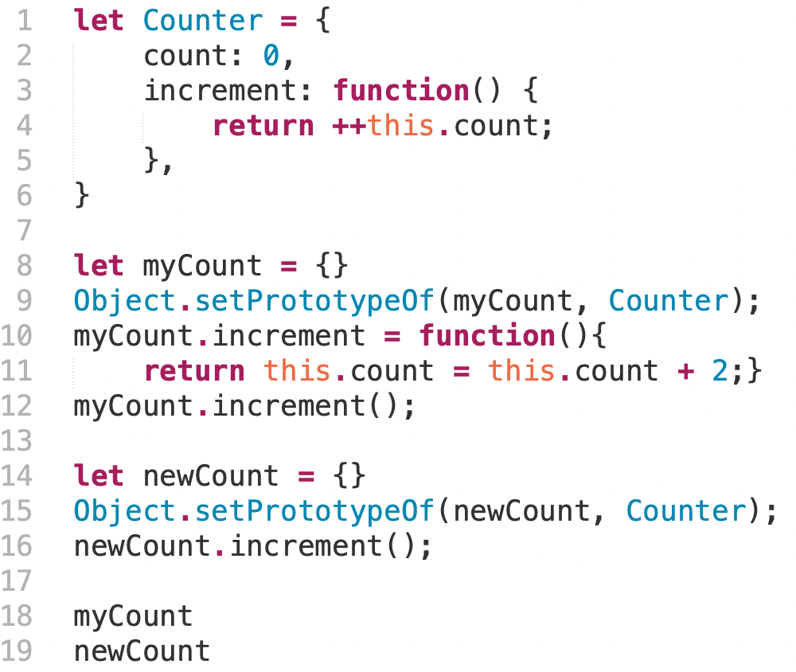

Hint: Object.setPrototypeOf(myCount, Counter) sets Counter to be the object myCount’s prototype.

1. __A___What are the public properties of the object myCount? (2pts)
2. Count with the value of 2, a function increment
3. Count with the value of 1, a function increment
4. Count with the value of 2
5. Count with the value of 1
6. __D__What are the public properties of the object newCount? (2pts)
7. Count with the value of 2, a function increment
8. Count with the value of 1, a function increment
9. Count with the value of 2
10. Count with the value of 1
11. (4pts) Consider the code below and the user interaction scenario.

The user loads the page at 9am. After exactly one minute (9:01), the user clicks the “Click Me!” button on the page.

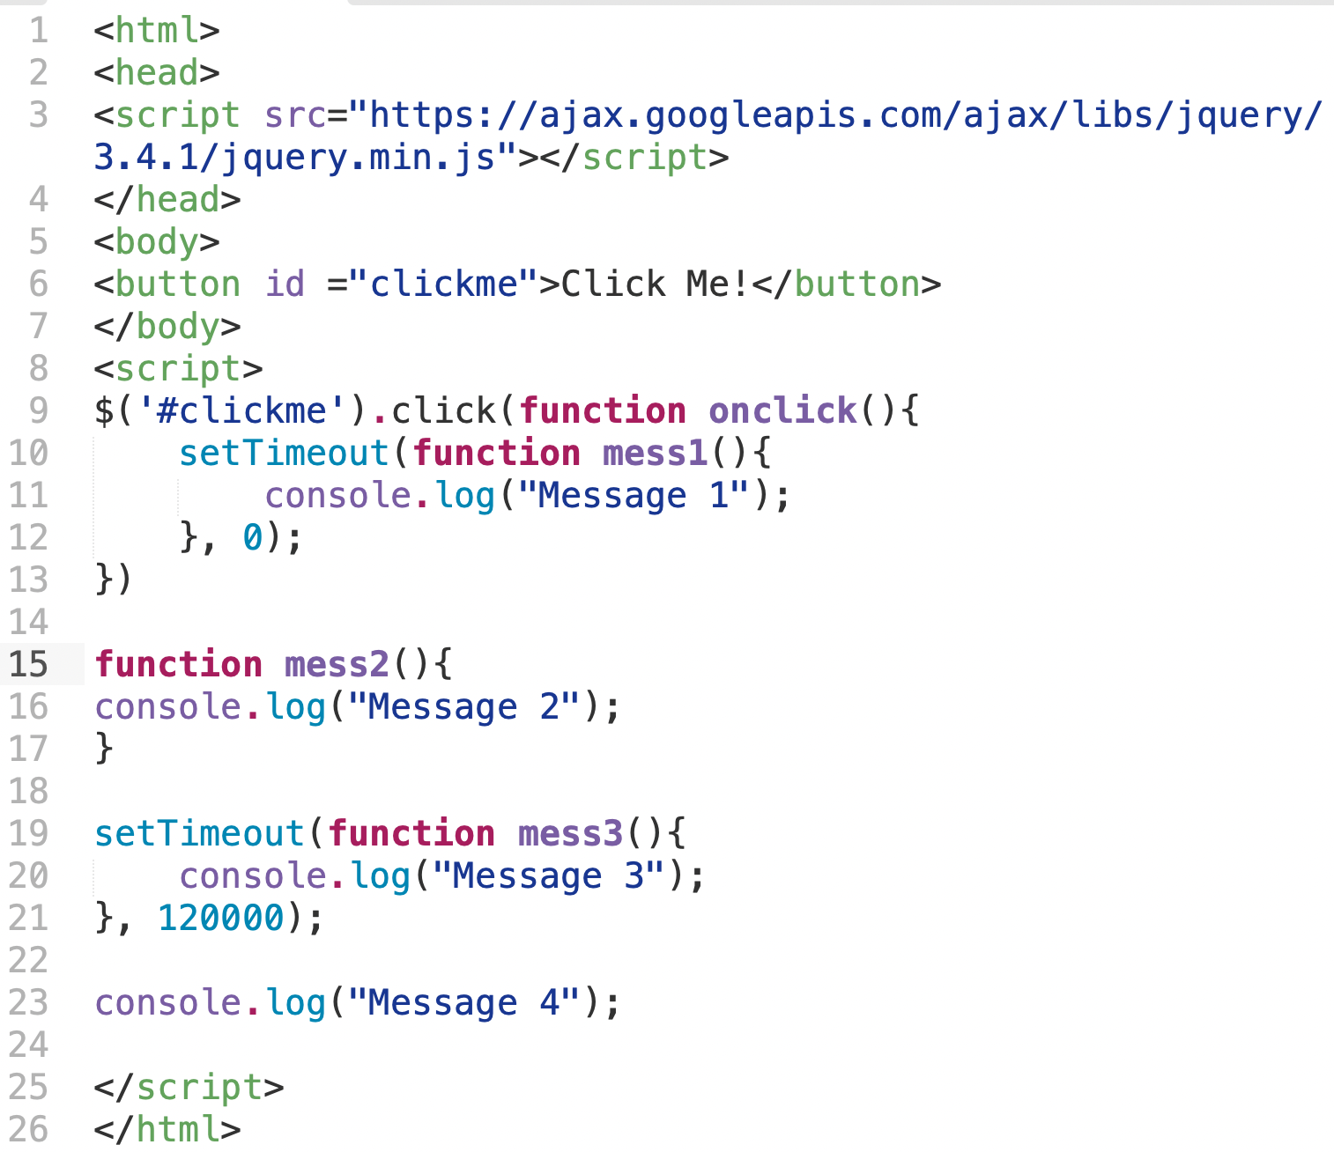

Which of the following are correct descriptions of what happens **in the callback queue** between 9 and 9:03 (**Please pick 4**)?

Answer: ______CFGH_____________________

1. mess3() is the first to enter the callback queue, because setTimeout() is loaded before the user clicks.
2. The stack first encounters mess2(), so that mess2() is the first to enter the callback queue.
3. onclick() is the first to enter the callback queue, and the first to leave.
4. mess1() gets directly added to the stack, since the timer is 0. mess1() doesn’t enter the callback queue.
5. onclick() doesn’t enter the callback queue, since the stack is empty when the button is clicked. onclick() is executed by the stack immediately after the click.
6. mess2() doesn’t enter the callback queue, since the function isn’t called.
7. mess3() enters the callback after the 2 minutes timer is up.
8. mess3() is the last to enter the callback queue.

# Vue.js (UI Architecture, MVC, Framework/Library/Tool, Vue) (20pts)

1. (2pts) A user Pat saw the following screen in Chrome on a laptop.

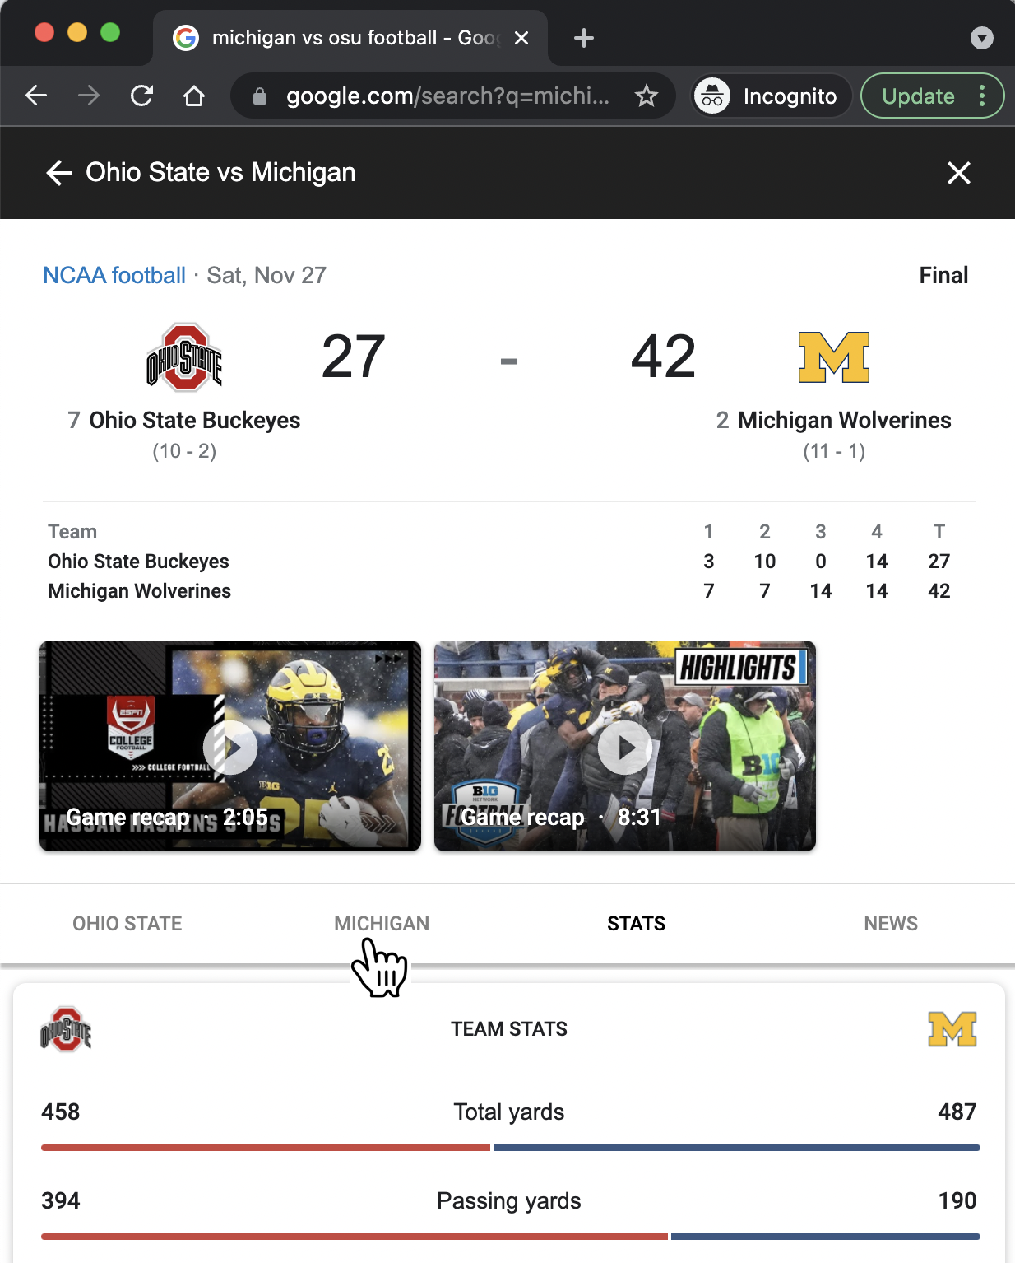

Now, describe the following process (bolded) in terms of what happens to the browser process, and what happens to the renderer process.

**Pat moved their cursor to the tab “MICHIGAN”, clicked, and saw information displayed under this tab.**

(1pt)The browser process …

Captures the location of the click

(1pt)The renderer process …

Renders the page (handles all javascript events)

1. Answer the following two questions on Library/Framework/Tool (4pts)
2. Django is a python-based free and open-source solution for creating complex, database-driven websites. Django consists of an object-relational database (“Model”), a web templating system (“View”), and a regular-expression-based URL dispatcher (“Controller”). Django emphasizes reusability and the “pluggability” of components.

____C_____Which of the following is correct about Django (2pts)?

1. It is a library because it has a collection of functions that help developers build web applications, but it doesn’t define how developers should structure their program.
2. It is a tool because it is language agnostic, it requires the use of python, Javascript, HTML/CSS. It also allows users to directly build the UI.
3. It is a framework because it defines how developers should structure their program, and developers will fill in slots.
4. Scitkit-learn is very helpful for my machine learning projects. When I’m using python to analyze large datasets, I can use algorithms from scikit-learn. It features various classification, regression, and clustering algorithms that I can use in python.



Scikit-learn is a____A___ (1pt)

1. Library
2. Framework
3. Tool

Please explain why (1pt)

Users run their code, users have control over their code. It’s language specific.

1. Please describe one reason why we want to use front-end frameworks such as Vue or React in web development (2pts).

Reduce the explicit coordination between model and view

# 

# 

# 

# 

# 

# Intentionally Left Blank

1. (12pts) Complete the following program using Vue.js framework.

Here’s what the HTML page looks like in the browser. When a user hovers over the color boxes, the Tshirt image updates. When the user presses “Add to Cart”, the number in “Cart” increases, the number “Item left” decreases. When “Item left” is 0, the button is disabled.

Here’s relevant CSS code for the website.

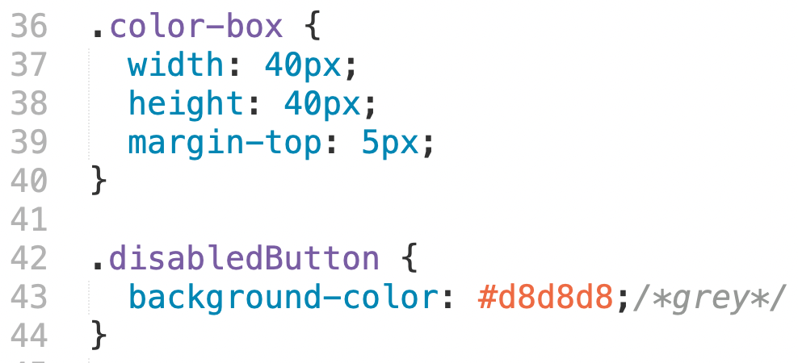

Here’s the Vue.js code

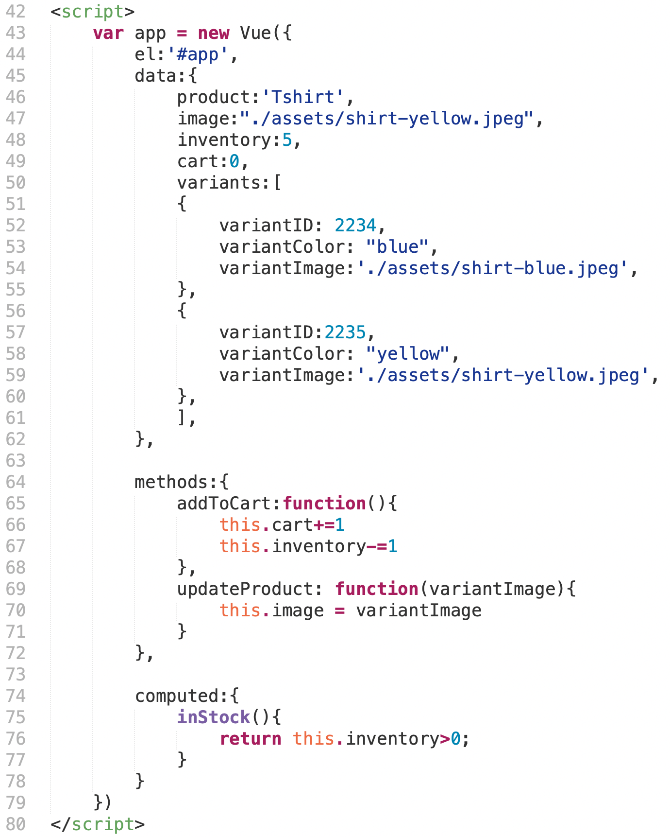

# 

# 

# 

# 

# 

# Intentionally Left Blank

Here’s what the HTML page looks like in the browser

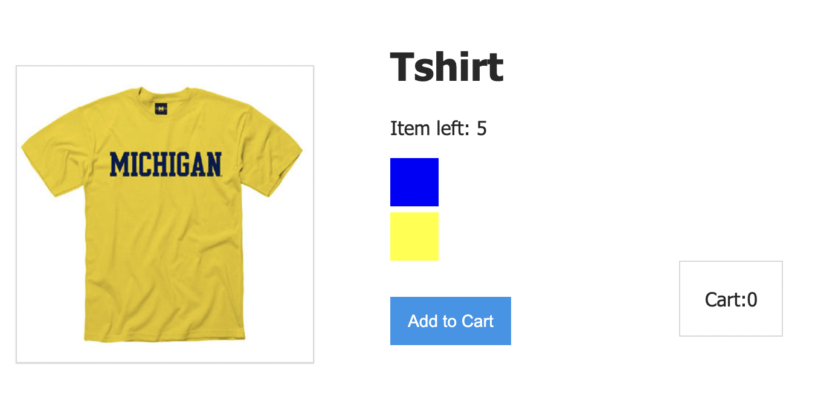

**Please use the following options to complete the HTML code on the next page. Each blank is worth 1pt. Not all options will be used.**

1. <div id = “app”>
2. <div class = “app”>
3. {{product}}
4. {{data.product}}
5. {{inventory}}
6. {{data.inventory}}
7. <img v-bind:src=”image”>
8. <img src = ‘./assets/shirt-blue.jpeg’>
9. class = “color-box”
10. style = “color-box”
11. v-for = “variant in variants”
12. v-bind:key = “variant.variantID”
13. v-bind:style = “variant.variantColor”
14. v-bind:style = “{backgroundColor: variant.variantColor}”
15. style = {{variant.variantColor}}
16. @mouseover = “updateProduct(variant.variantImage)”
17. v-on:click=”addToCart”
18. v-on:click=”updateProduct”
19. v-bind:class= “{disabledButton : !inStock}”
20. class=disabledButton
21. {{cart}}
22. {{inStock}}

<body>

1____________

<div class = "product">

<div class = "product-image">

2__________________

</div>

<div class = "product-info">

<h1>3__________</h1>

<p>Item left: 4___________</p>

<div 5____________

6____________

7____________

8____________

9____________>

</div>

<button 10___________

11___________ >Add to Cart</button>

<div class ="cart">

<p>Cart: 12__________</p>

</div>

</div>// div product info

</div> //div class product

</div>

</body>

# User-Centered Design (40pts)

1. (6pts) Inspect the following user-centered design and development scenarios. Assuming you are the chief designer on the project. For each scenario, please determine which method from the list below would be the most appropriate and explain why. Please write the corresponding letter in the blank.

| A. Observation | B. Think Aloud  Protocol | C. Semi-Structured  Interview | D. High-fi Prototyping | E. Heuristic Evaluation |
| --- | --- | --- | --- | --- |

1. Your team designed a new feature in a social media app X_Xchat. Your team found the feature was very well received by users in Michigan. However, users in California didn’t use the new feature as much. Your team wants to know why users in California didn’t use the new feature.

Method (1pt): ____C_____

Reason (1pt): you need to answer why questions. All other methods are not able to answer why questions.

Have to talk to users to understand their preferences and concerns

1. Your team built a bus route recommendation app that allows UM students to find the fastest route between two points on campus. Your team just finished a functional prototype and wanted to understand how UM students will use the app to find routes.

Method (1pt): ____B______

Reason (1pt): have to have the users use it to be able to understand whether they can complete the tasks successfully. Observation isn’t ideal because want to understand users’ decision making process, and observation would be expensive and won't’ get the most data out of it. Same for interview.

1. Your team is building an online meeting platform that supports meeting participants to take notes. After storyboarding, you decided on a list of functionalities that your platform will provide. Your goal now is to figure out the task flows of your platform, the color scheme, and the transitions between different tasks.

Method (1pt): ____D______

Reason (1pt): because need to figure out the screen details, task flows, high-fi prototyping is necessary

1. (6pts) Inspect the following user-centered design and development scenarios. Assuming you are the chief designer on the project. For each scenario, please select which is the best method to use.
2. Your team is considering building a social fitness app that encourages users to exercise with their friends and share fitness data among friends. Before building the app, your team wants to understand users’ preferences and concerns around privacy e.g., why they want or don’t want to share fitness data.

___B_____Which is the most appropriate method to use and why? (2pts):

1. Observation because the goal is to observe users’ natural behaviors on data sharing to protect their privacy when they use the app.
2. Semi-structured interview because the goal is to let users articulate their preferences and concerns around privacy.
3. Think-aloud protocol because it’s important to understand how users perform in existing similar apps.
4. Heuristic evaluation because it’s important to understand which features of the app are protecting or violating users’ privacy.
5. High-fi prototyping because a prototype is necessary for further evaluation of users’ privacy preferences in the app.
6. Your team wants to build cooking devices for blind people. Before you start, your team wants to understand blind people’s natural cooking behaviors at home.

____A____Which is the most appropriate method to use and why? (2pts):

1. Observation because the goal is to observe how blind users’ cook, and understand the limitations of existing cooking equipment at the blind users' homes.
2. Semi-structured interview because the goal is to let blind users share their experiences cooking at home, which cooking equipment they use, and what challenges they have encountered when cooking.
3. Think-aloud protocol because it’s important to understand users’ intentions and investigate whether users would be able to successfully complete a recipe with existing cooking equipment.
4. Heuristic evaluation because it’s important to understand which factors are preventing users from successfully completing a recipe using existing equipment.
5. High-fi prototyping because a prototype is necessary for further evaluation of how users may use the novel cooking equipment to cook.
6. Your team built a music recommendation app that allows users to socialize with each other. Your team just finished a high-fidelity prototype and want to inspect the usability of the app. Your goal is to inspect lower-level usability bugs that can be quickly fixed before you recruit users.

___D_____Which is the most appropriate method to use and why? (2pts):

1. Observation because the goal is to observe how users socialize with each other in a music app.
2. Semi-structured interview because the goal is to let users share their experiences socializing with each other in a music app.
3. Think-aloud protocol because it’s important to understand users’ intentions and investigate whether users would be able to successfully complete tasks in the app.
4. Heuristic evaluation because it’s a discount usability technique that allows you to quickly identify usability bugs.
5. High-fi prototyping because a prototype is necessary for further evaluation of how users socialize with each other in a music app.
6. _____A____Which of the following is NOT correct about ideation in human-centered design? (2pts)
7. When brainstorming, we need to make sure the ideas are feasible and are supporting the main functionalities of the product.
8. We want as many ideas as possible at the initial phase.
9. It's sometimes easier to explain your ideas to other teammates through visual medium rather than through words.
10. It’s encouraged to think out of the box when coming up with ideas.
11. Please describe one commonality between ideation and prototyping (2pts)

Elicit user feedback at early stage of development

1. Your design team is interested in developing technologies to support collaborative learning in 8th grade classrooms. You brainstormed 50 ideas and wanted to quickly test which ideas teachers like or not like.

____C____Which of the following prototyping methods would you use (1pt)?

* 1. Wireframe
  2. Wizard-of-oz
  3. Storyboards
  4. Paper prototypes

Please explain why (1pt):

Rapid testing, visualize ideas to get feedback

1. Your design team is building an AI-powered robot to help cultivate curiosity in kids. Before the AI capabilities are complete, you want to make design decisions on how kids could interact with the robot.

___B_____Which of the following is the best description of which method to use and why? (2pts):

1. Wireframe because users need a visual representation of the user interface to understand its functionality.
2. Wizard-of-oz because it gives users initial experience of the different characteristics of the pedagogical conversational agent.
3. Storyboards because it allows us to get user feedback on how they want to use and interact with the agent.
4. Paper prototypes because it’s cheaper and quicker compared to wireframes and is especially useful for feedback at early stages of development.
5. Identify one upside and one downside of the method *Cognitive walkthrough.*

Upside (1pt):

Cheap, easy to do, don’t cost users

Downside (1pt):

May not get gauge severity of issues

Not for skilled use

May guess users in the wrong direction

1. ___B_____Which of the following is NOT correct about think-aloud protocol (2pts)?
2. It is very easy to learn and implement. Novice designers can do this as well.
3. It is especially useful as a group activity, because it supports ideas exchange from the perspectives of both designers and developers and increases buy-in.
4. With multiple users, it’s possible to gauge the severity of different usability issues identified.
5. It’s a more expensive (costing more time and resources) method compared to discount usability techniques
6. During a think-aloud, what would you do if a participant gets stuck on a task for 5 seconds? (2pts)  
   Wait
7. ____C_____During a think-aloud, if you see a participant do something unexpected and you want more information about why they did it, what is the most appropriate thing to do? (2pts)
8. Ask the participant to explain why they did the unexpected thing
9. Have the participant repeat the activity and think aloud more during the repeat
10. Make a note and wait until the end of the think-aloud to ask about it
11. Don’t do anything because it’s not the purpose of this think-aloud activity
12. During a think-aloud, what is one good way to encourage a participant to talk? (2pts)

Please keep talking

1. ____D_____Which of the following is NOT correct about task selection in preparation for a think-aloud study? (2pts)
2. The task needs to be concrete, e.g., create a playlist using this music app.
3. Avoid bending tasks in direction of what our design best supports
4. Tasks need to reflect how real users user the product
5. To fully evaluate the entire product, we may task the user to freely explore the product and observe what issues emerge.
6. Pretend you asked two participants to practice thinking aloud by solving the math problem below. Which participant’s response is better, and why? (2pts)

197

+55

**Participant A:** Well first I start with the ones column, so I’m going to add 7 and 5, which makes 12. Then I’m going to write the 2 as the ones digit of my answer, then there’s an extra 10. So I have to carry the 1 and write it above the 9. Now I’m going to add 1 and 9 and 5, which makes 15. So again I’m going to write the 5 in the answer digit and carry the 1 over to the hundreds column. Now I have to add 1 and 1, which is 2, so I’m going to write the 2 below. Then I have an answer of 252.

**Participant B:** Well 7 and 5 is 12. The 2 goes down here and carries the 1. 1 and 9 and 5 is 15. The 5 goes down here and carries the 1 again. 1 and 1 makes 2, so it’s 252.

Answer (1pt): ___Participant B___

Why? (1pt)

Didn't explain

Here is a set of Nielsen’s heuristics from Heuristic Evaluation. These will be used for the next two questions.

| H-1: Visibility of system status  H-2: Match between system & real world  H-3: User control & freedom  H-4: Consistency & standards  H-5: Error prevention | H-6: Recognition rather than recall  H-7: Flexibility and efficiency of use  H-8: Aesthetic and minimalist design  H-9: Help users recognize, diagnose, recover from errors  H-10: Help and documentation |
| --- | --- |

1. (3pts) Apply heuristic evaluation. Examine the screenshot below from Ebay.com (an e-commerce platform). Pat wanted to buy an item. They first checked the item description page and wanted to contact the seller of the item. After clicking “Contact the Seller”, Pat was directed to the following interface which asked Pat to enter the 12-digit item number. Pat didn’t remember and had to go back to the item description page to find out.

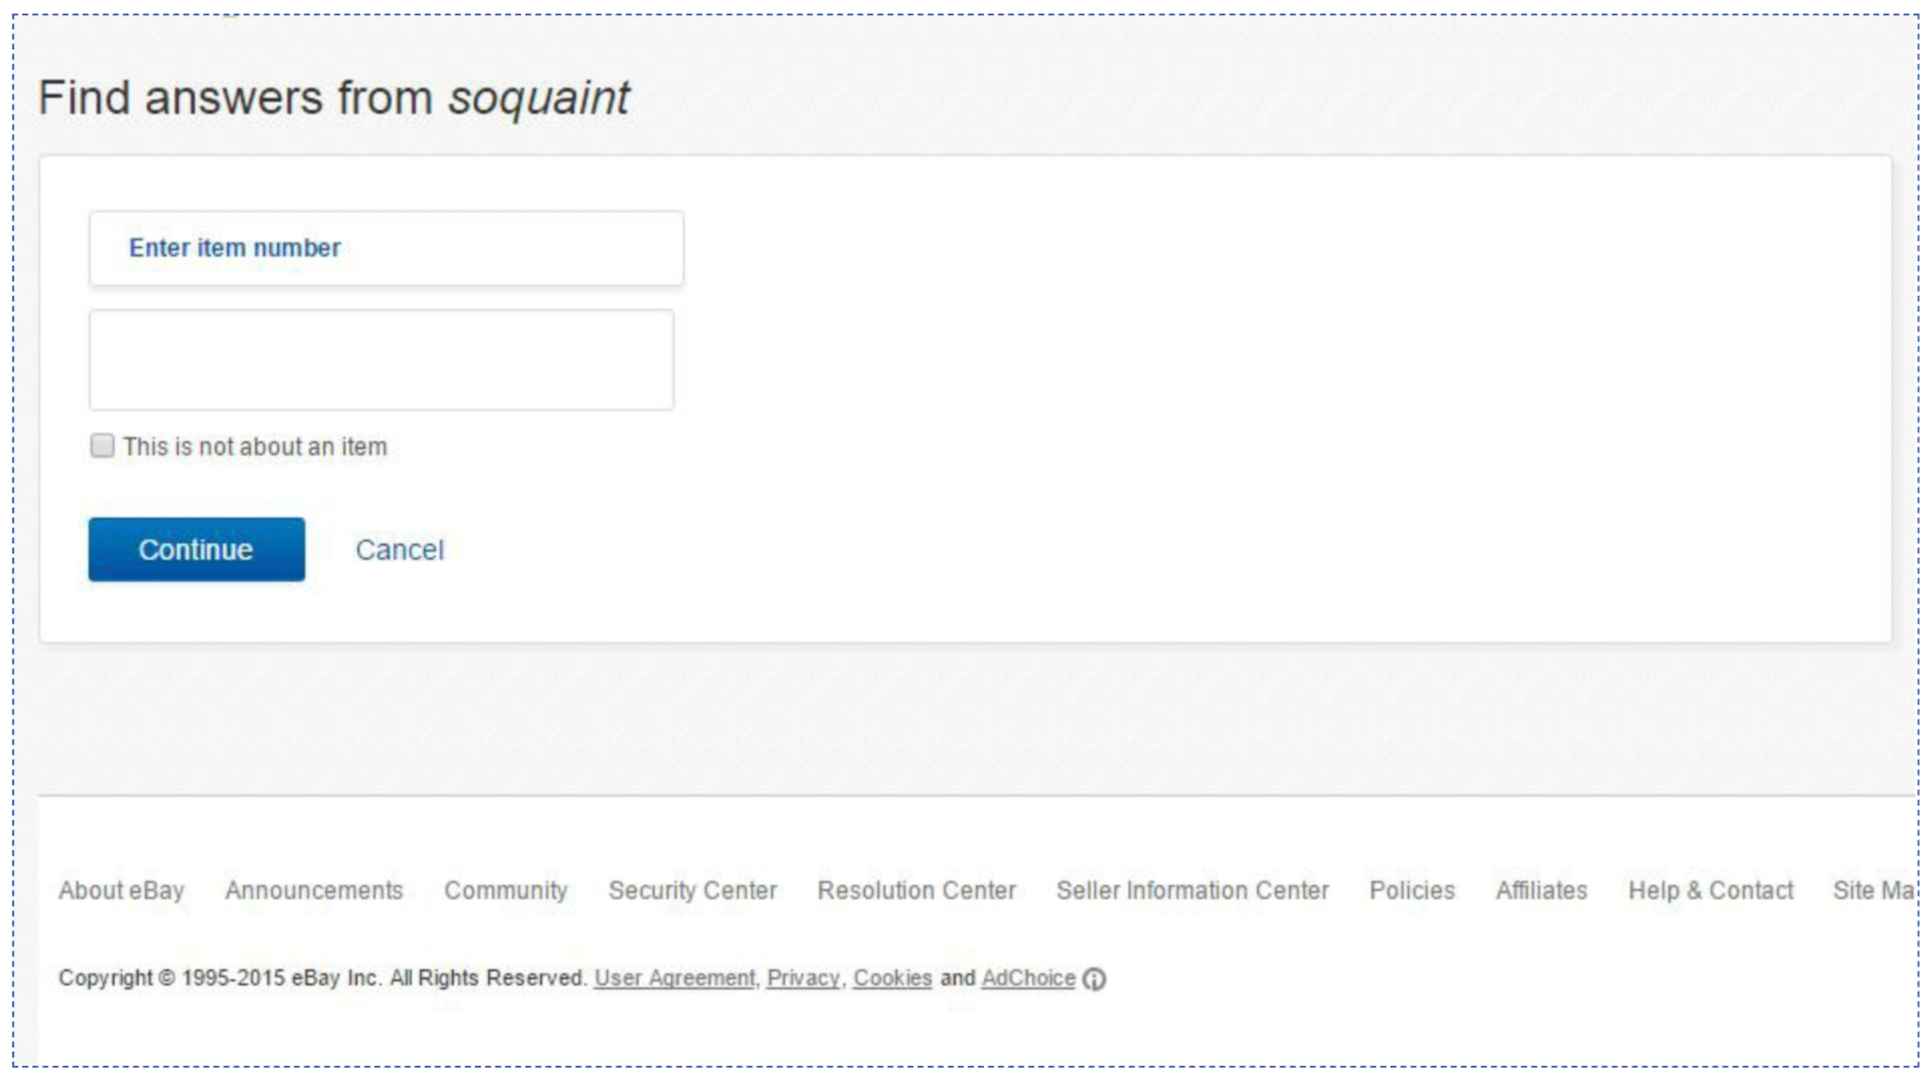

(a)Which is the most salient heuristic rule that this violates? (1pts)

(Write either the number, e.g. H-1, or the full text, please write **one** answer)

H-6

(b) Please propose a redesign to fix the problem you identified: (2pts)

Provide a menu of recently viewed items to choose from

Along the lines of providing support on this page

If they say going back to the previous page to find it or give tutorial, 0

1. (3pts) Apply heuristic evaluation. Examine the screenshot below from ebay.com (an e-commerce platform). Pat wanted to sell a book on ebay. They first entered the ISBN number of a book and clicked “get started”, the system didn’t give a confirmation message on whether the ISBN number was found and proceeded to the next step. In the next step, the system asked Pat to choose a listing form (i.e., fill out a form about the specifics of the listing. Pat was very confused.

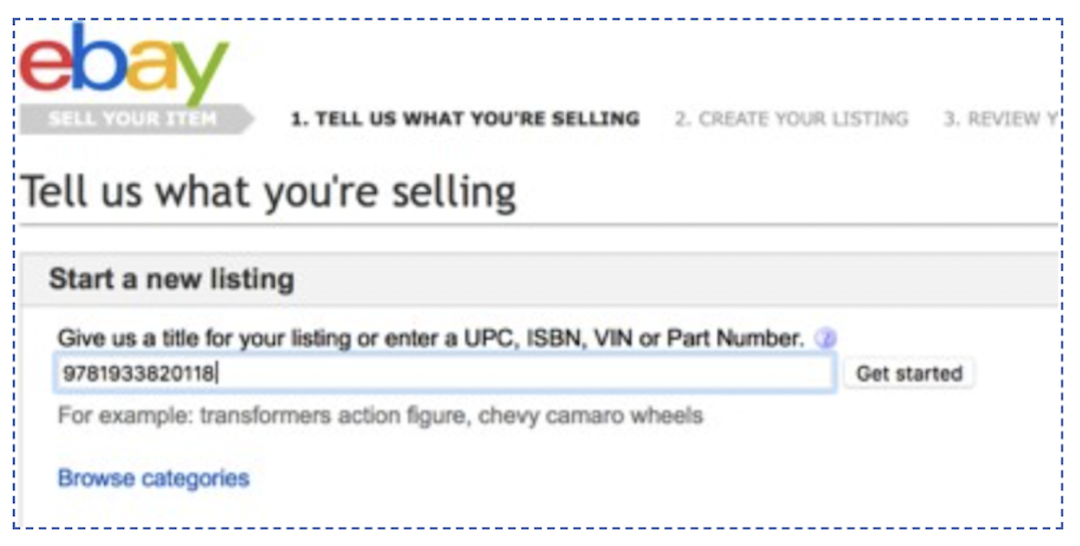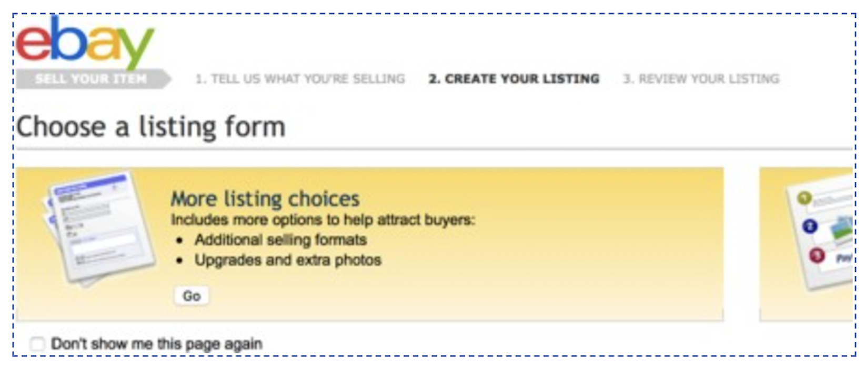

(a)Which is the most salient heuristic rule that this violates? (1pts)

(Write either the number, e.g. H-1, or the full text, please write **one** answer)

H-1

(b) ___B___Which of the following redesigns is the best to fix the problem you identified? (2pts)

1. Include a tutorial for novice users on how to sell an item to increase learnability.
2. Provides a confirmation message to let Pat know whether the book is found or the ISBN number is invalid before proceeding to the next step.
3. On the “Choose a listing form” page, provide a tour for users to explain what each option is about.
4. Include an introduction page before the first step to let novice users know they need to fill out the listing form first before they can review the listing item.

# Accessible and Universal Design (12pts)

1. (4pts) Consider block-based programming, like Scratch.

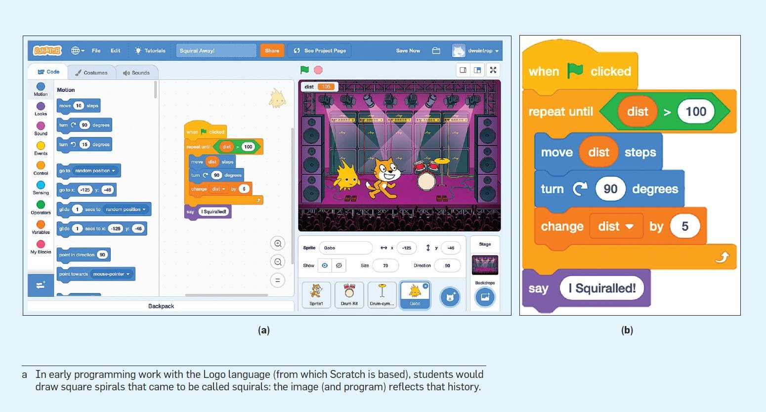

(a)____D_____Which of the following is correct about the accessibility of textual programming and block-based programming for people with low vision (2pts).

1. Textual programming is more accessible because it can be processed by screen readers, whereas blocks are hard to interpret by screen readers.
2. Textual programming is more accessible because people with low vision are able to read texts in black-and-white interfaces.
3. Block-based programming is more accessible since it reduces the cognitive load required in programming.
4. Block-based programming is more accessible since blocks have better contrast than texts that low-vision users could perceive.

(b) For people with motor disabilities (low manual dexterity), which one is more accessible? Block-based or textual programming?

Answer (1pt):__textual programming___

Please explain why (1pt):

Require less mid-air gestures, require less precis control, such as drag and drop

Anything else wrong

1. (4pts) Consider how universal design principles are used in the following scenarios.

| A. Equitable Use  B. Flexibility in Use  C. Simple and Intuitive Use  D. Perceptible Information | E.Tolerance for Error  F. Low Physical Effort  G. Size and Space for Approach and Use |
| --- | --- |

(i) Flat panel light switches

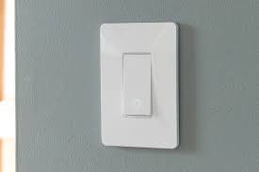 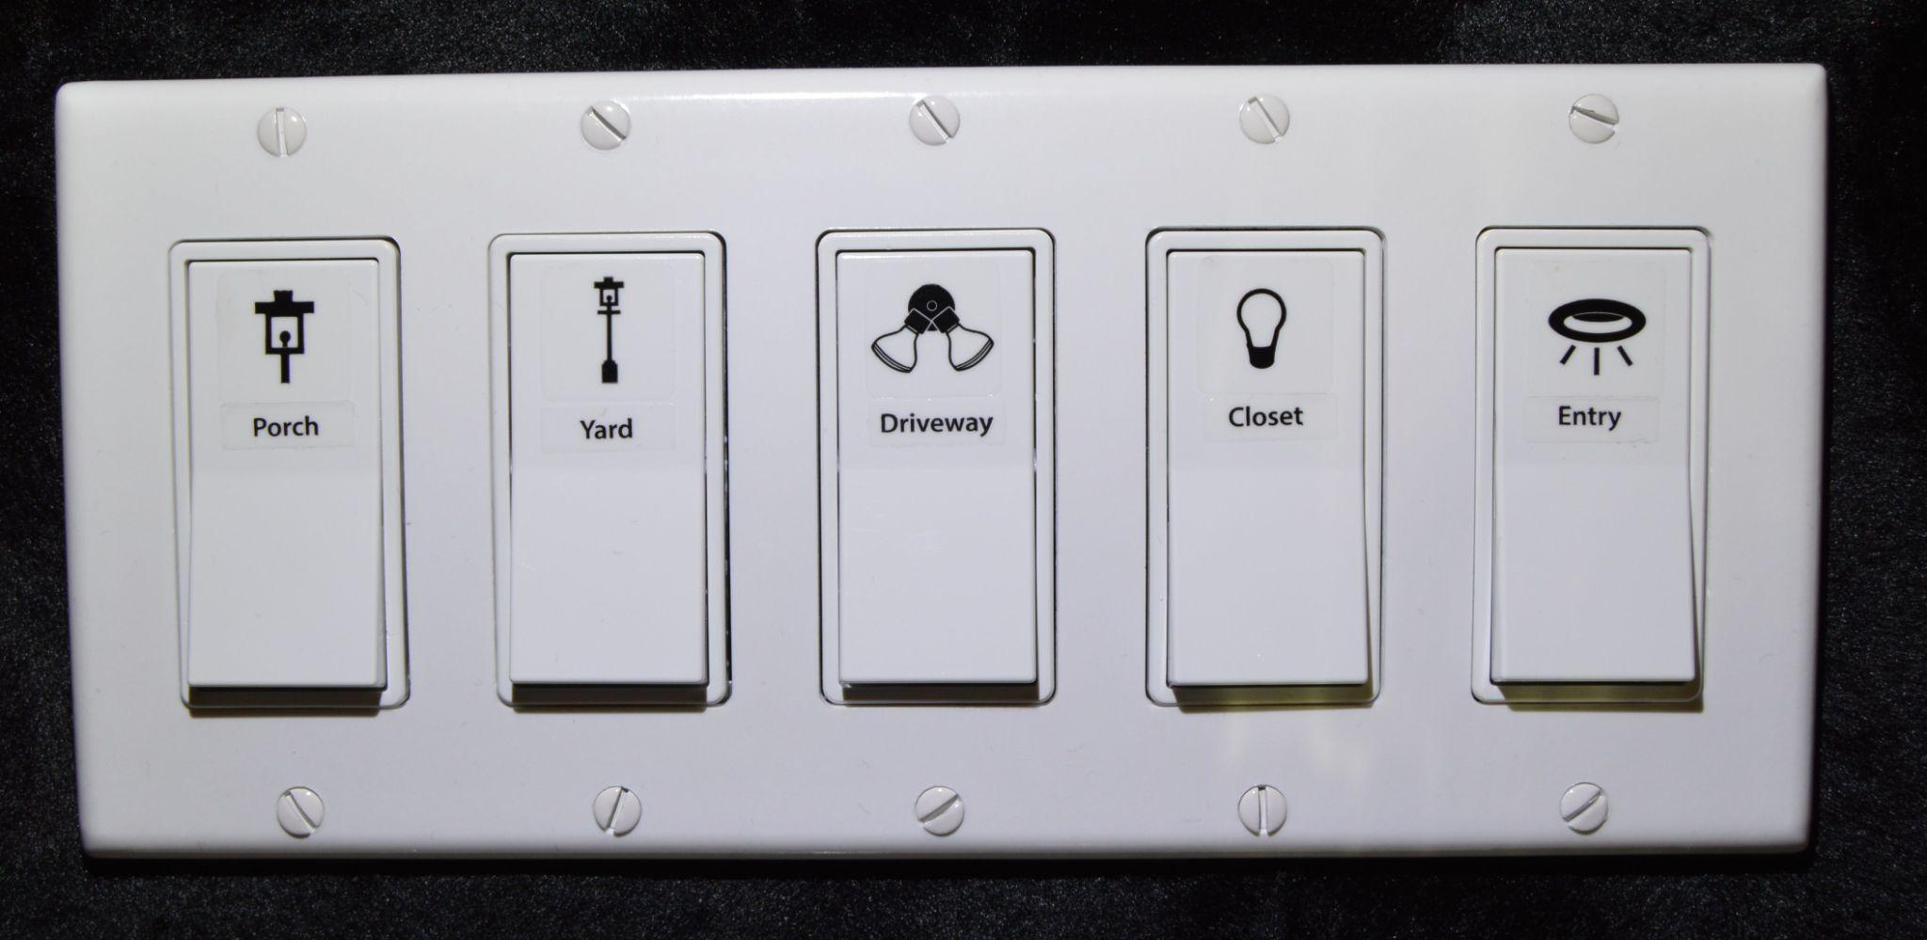

Design X Design Y

Your team moved from Design X to Design Y considering the universal design principles. Which design principle was the most highlighted in the transition? (Pick **one answer from the list above**) (1pt)

D

Please explain why (1pt)

Includes logs and texts for explanation

(ii) Reception desk

 

Design X Design Y

Your team moved from Design X to Design Y considering the universal design principles. Which design principle was the most highlighted in the transition? (Pick **one answer from the list above**) (1pt)

G

Please explain why (1pt)

Designed for people with different heights, e.g., kids can go to the lower side of it

1. (4pts) Consider how universal design principles are used in the following scenarios.

(i) Emergency stop key on treadmills

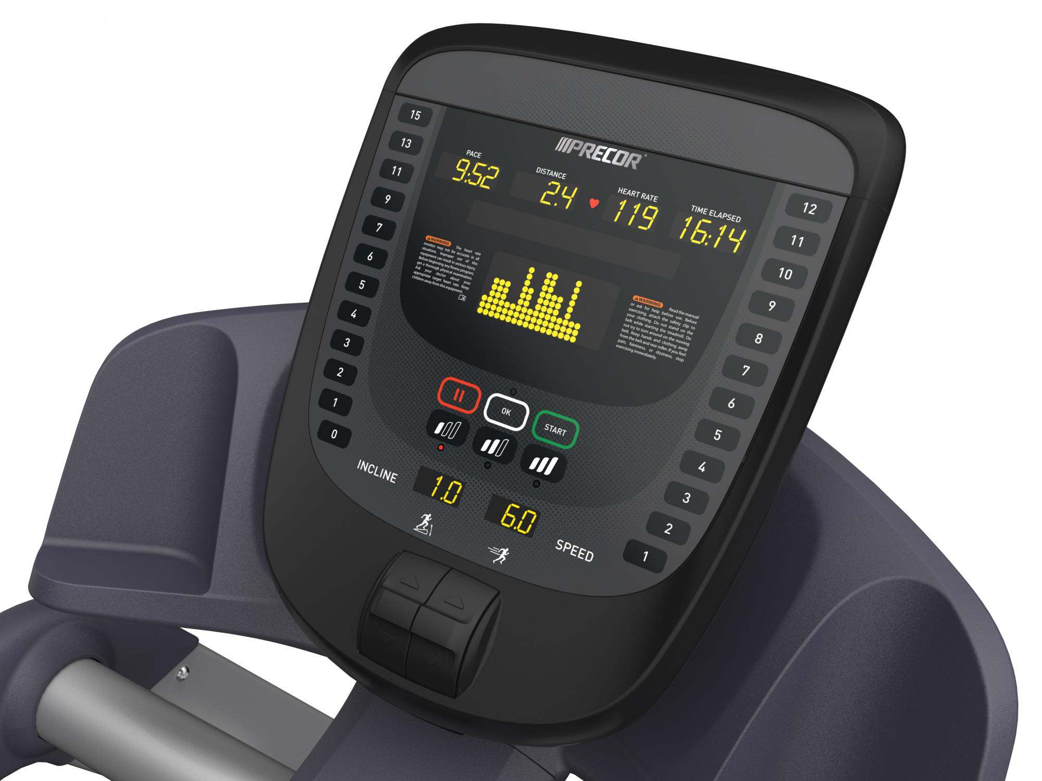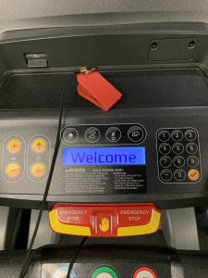

Design X Design Y

Your team moved from Design X to Design Y (added an emergency stop key) considering the universal design principles. Please select which universal design principle is the most highlighted in the transition and why (2pts)

Answer: ______C______

1. Equitable use since people with different abilities can use the emergency stop well.
2. Flexibility in use because users have diverse ways to trigger the emergency stop.
3. Tolerance for error because it’s easy to trigger the emergency stop so it’s protecting users’ safety on the treadmill.
4. Size and space for approach and use because people with different heights or body size can use the emergency stop

(ii) Ramp entrance

 

Design X Design Y

Your team moved from Design X to Design Y considering the universal design principles. Please select which universal design principle is the most highlighted in the transition and why (2pts)

Answer: ____A________

1. Equitable use since people with different abilities can use the ramp entrance well.
2. Low physical effort because it reduces the effort required for users to go off the ramp.
3. Flexibility in use because it gives users multiple options in going off the stairs
4. Tolerance for error because people are less likely to make mistakes in this context, e.g., fall at the stairs.

==========END============

Thank you and happy holidays!